Damping Estimation
Theory:
The (most basic) idea is to fit an envelope to the amplitude of the signal, see figure 1 below.

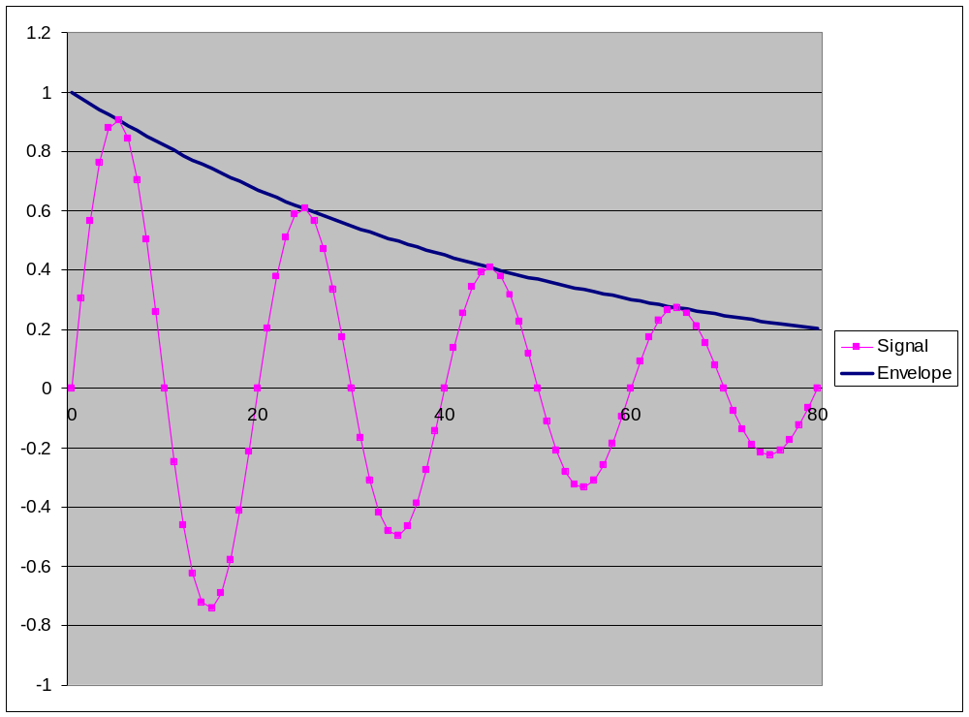
Figure 1: Basic example of decaying signal showing amplitude envelope.
This can be done by a variety of techniques, including using a Hilbert transform. Here it is done by calculating the root mean squared energy over a sliding window. Then assume (big assumption) that the decay/damping is exponential and use this assumption to calculate a damping coefficient (i.e. the half life (tbc) of the exponential curve).
So first read in data and set up time and signal vectors. Also set up length of window:
window = 10 (This may well change)
time column vector same length as time series
signal column vector same length as time series
square_data column vector same length as time series
data_length scalar length of time series
av_z1, av_z2 scalars data points
av_time1 scalar associated time point
av_time2 scalar associated time point
lambda scalar decay coefficient
amplitude scalar Initial amplitude of decay curve
decay_envelope column vector same length as time series
First calculate the mean of the input signal and subtract it from data to give time series normalized about zero.
av = mean(signal)
signal = signal - av
Then calculate the squared amplitude of the normalized signal
for i = 1, data_length
square_data(i) = signal(i)*signal(i)
end i

This should give you something like figure 2, below:
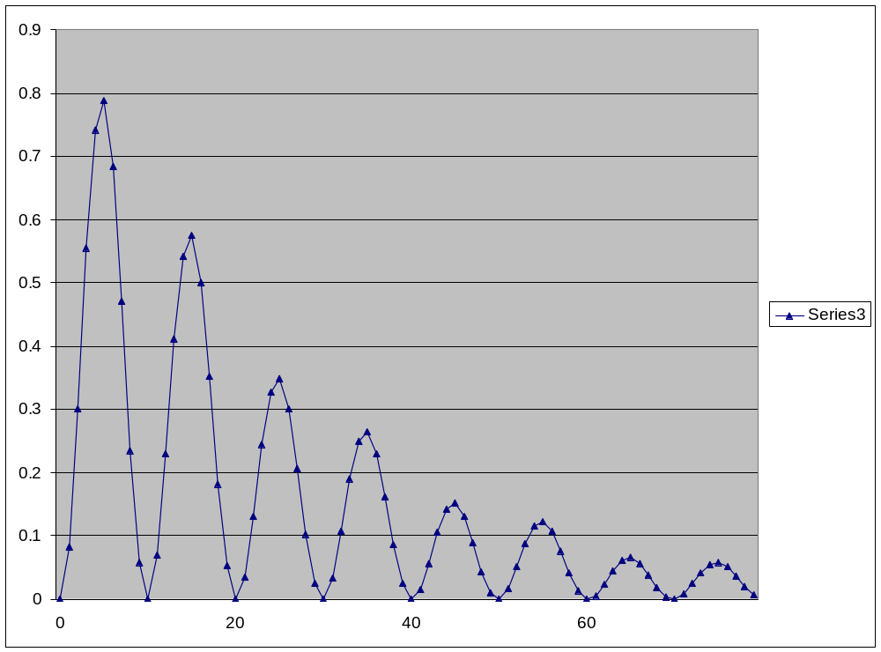
Figure 2: Squared amplitude of signal given in Figure 1
Now apply a sliding window and calculate the root mean square energy. This is given by the equation:
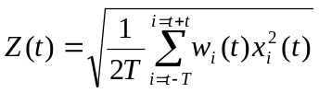
Where w_{i}(t) is a window function, in our simple case we use a rectangular window so w_{i}(t) = 1
data_length = size(square_data)
z=zeros(data_length)

for i=(window+1):data_length-window
z(i)=sqrt((2/(2*window+1))*sum (square_data(i-window:i+window)))
end

This should give the envelope of the squared signal which will vary slightly depending on the size of the window, see figure 3, below.
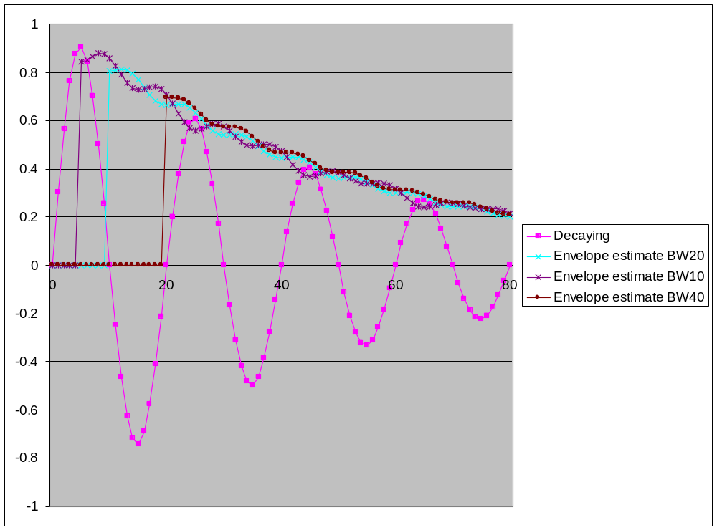
Figure 3: Envelope estimates of the signal given in Figure 1
We now take the envelope function and assume it can be estimated by an exponential decay function, i.e. something of the form y=Ae^{-λt}. So this means we have to estimate A and λ. To do this we take the first and last non-zero values (z₁,t₁) and (z₂,t₂) of the envelope estimate and assume they are points on the exponential curve. So
y=Ae^{-λt} taking natural logs of both sides gives

lny = lnA – λt this is a straight line of the form y = mx + c

So if we substitute in our two know points (z₁,t₁) and (z₂,t₂) we can solve for m and c to get:

m = -λ = (lny₂ – lny₁)/(t₂ – t₁)

c = lnA = lny₁ + kt₁

And then we can calculate our entire decay function y=Ae^{-λt}

%Take first non-zero z-value
av_z1 = z(window+1)
av_time1 = time(window+1)

%Now take last non-zero z-value
av_z2 = z(length(signal)-window)
av_time2 = time(length(signal)-window)

%Calculate decay constant
lambda = (-1)*(log(av_z2)-log(av_z1))/(av_time2- av_time1)
intercept = log(av_z1) + (lambda*av_time1)
amplitude = exp(intercept)

%Calculate decay envelope
decay_envelope = zeros(data_length)
decay_envelope = amplitude * exp(-lambda * time)

The output of this algorithm should be the decay coefficient, lambda.

Advanced algorithm:
Here we consider the case where the data may not be symmetric and where we might want to chose between an exponential and a linear decay envelope.
If the signal is not symmetric we consider the peaks (positive signal) and troughs (negative signal) separately. To do this (for peaks first) we excise the parts of the signal which, after normalization, are negative and concatenate the remaining positive data, see Figure 3 below. Whilst doing this we monitor how many of the data points are positive.

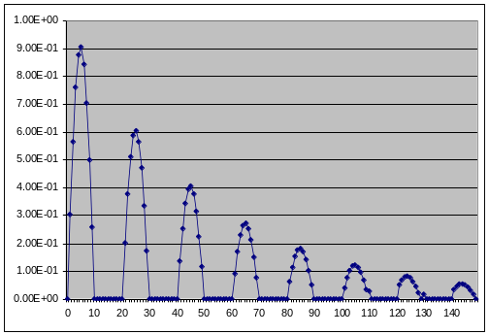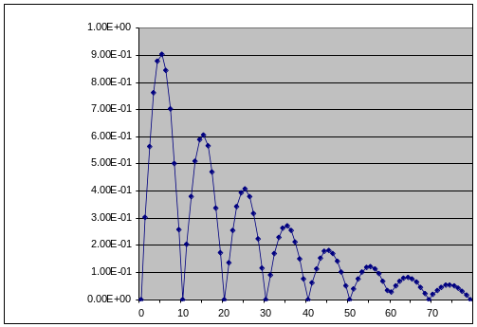
Figure 4: Generating Peaks-only data by excising negative data and concatenating positive data-points

peaks = zeros(size(signal),1)
new_time = zeros(size(signal),1)
j=0

for i = 1:size(signal)
if(signal(i) >=0)
j=j+1
peaks(j) = signal(i)
new_time(j) = j;
end
end

We now apply the sliding window to the concatenated data (peaks) and calculate the root mean square energy as in the case of symmetric data. Then, as before, the exponential decay function can be calculated, but this time based only on the windowed, positive data.
square_peaks = peaks.*peaks
truncated_time = size(nonzeros(new_time))

%apply sliding window and calculate root mean square energy
z=zeros(size(signal),1)
for i=(window+1):truncated_time-window
z(i)=sqrt((2/(2*window+1))*sum (square_peaks(i-window:i+window)));
end

Having calculated the decay envelope we now calculate an error, the difference between the envelope signal and the exponential decay envelope. NB this can only be calculated for the section of data where the envelope was calculated.
exp_error = 0
for i=(window+1):truncated_time-window
exp_error = exp_error + ((z(i) - decay_envelope(i))*(z(i)-decay_envelope(i)))
end

Now we fit a linear decay envelope to the root mean square energy (based on the windowed, positive data).Sp we assume the envelope function can be estimated by something of the form y=mt+c. So we have to estimate m and c. To do this we take the first and last non-zero values (z₁,t₁) and (z₂,t₂) of the envelope estimate and assume they are points on the linear envelope. So
y=mt+c

So if we substitute in our two know points (z₁,t₁) and (z₂,t₂) we can solve for m and c to get:

m = (y₂ – y₁)/(t₂ – t₁)

c = y₁ - mt₁

And then we can calculate our entire decay function y=mt+c

%Now calculate a linear envelope
gradient = (av_z2 - av_z1)/(av_time2 - av_time1)
intercept2 = av_z1 - (gradient * av_time1)

linear_envelope = zeros(size(signal),1)
for i = 1: size(nonzeros(new_time))
linear_envelope(i) = gradient*new_time(i) + intercept2
end

Now calculate the linear error, the difference between the envelope signal and the linear decay envelope. As before this is only calculated for the section of data where the envelope was calculated.
lin_error = 0
for i=(window+1):truncated_time-window
lin_error = lin_error + ((z(i) - linear_envelope(i))*(z(i)-linear_envelope(i)))
end

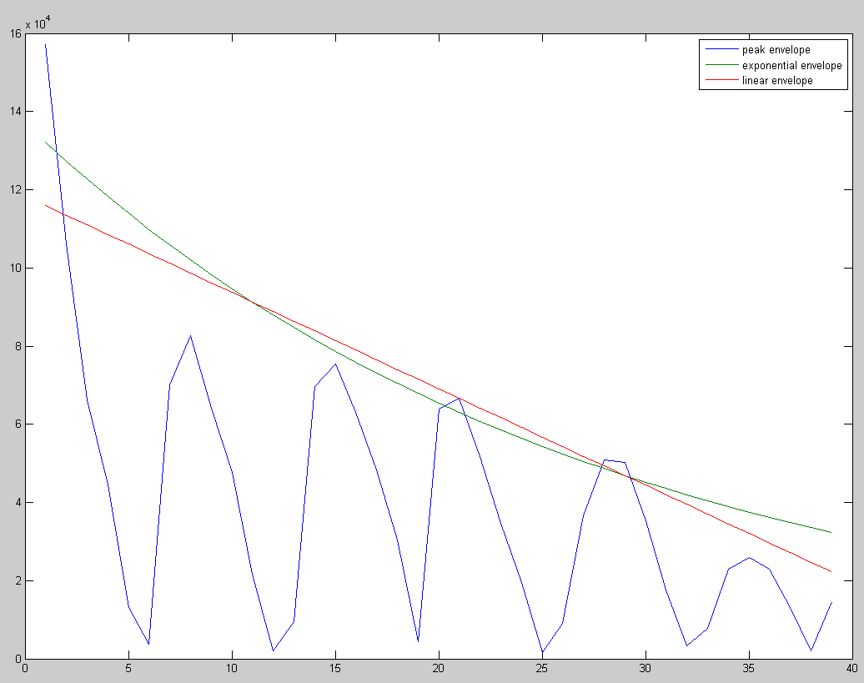
Figure 5: Envelope of peaks-only data together with exponential decay and linear envelopes
We now take whichever curve (linear or exponential) gives the smaller error and use this to generate a decay curve which encompasses the original duration of the input time series.
%Now regenerate full length fitting curve
%Find maximum amplitude of signal and time at which that occurs

[max_signal, max_index] = max(signal)

if (exp_error <= lin_error)
lambda2 = lambda * length(nonzeros(new_time))/length(signal)
amplitude = max_signal/exp(-lambda2*max_index)
decay_envelope = zeros(size(signal),1)
decay_envelope = amplitude * exp(-lambda2 * time)
else
linear_envelope = zeros(size(signal),1)
gradient2 = gradient * length(nonzeros(new_time))/length(signal)
intercept2 = max_signal - (gradient2 * max_index)
linear_envelope = gradient2*time + intercept2
end

Now repeat the whole algorithm but using the troughs instead of peak. So now we excise the parts of the signal which, after normalization, are positive and concatenate the remaining negative data. Whilst doing this we monitor how many of the data points are negative.
troughs = zeros(size(signal),1)
new_time = zeros(size(signal),1)

for i = 1:size(signal)
if(signal(i) <=0)
j=j+1
troughs(j) = signal(i)
new_time(j) = j;
end
end

As before we apply the sliding window to the concatenated data (peaks) and calculate the root mean square energy as in the case of symmetric data. Then, as before, the exponential decay function can be calculated, but this time based only on the windowed, negative data.
square_troughs = troughs.*troughs
truncated_time = size(nonzeros(new_time))

%apply sliding window and calculate root mean square energy

z=zeros(size(signal),1)
for i=(window+1):truncated_time-window
z(i)=sqrt((2/(2*window+1))*sum (square_troughs(i-window:i+window)));
%z(i) = z(i) + av;
end

As before calculate the error between the envelope signal and the exponential decay envelope. Recall this can only be calculated for the section of data where the envelope was calculated.
Then we fit a linear decay envelope to the root mean square energy (based on the windowed, negative data). Then calculate the linear error, the difference between the envelope signal and the linear decay envelope. As before this is only calculated for the section of data where the envelope was calculated.
As with the positive data we now take whichever curve (linear or exponential) gives the smaller error and use this to generate a decay curve which encompasses the original duration of the input time series. Note there are differences in the signs when calculating the intercept for the negative data/
%Now regenerate full length fitting curve
%Find maximum amplitude of signal and time at which that occurs

[min_signal, min_index] = min(signal)

if (t_exp_error <= t_lin_error)
t_lambda2 = t_lambda * length(nonzeros(new_time))/length(signal)
t_amplitude = min_signal/exp(+t_lambda2*min_index)
t_decay_envelope = zeros(size(signal),1)
t_decay_envelope = t_amplitude * exp(-t_lambda2 * time)
else
t_linear_envelope = zeros(size(signal),1)
t_gradient2 = t_gradient * length(nonzeros(new_time))/length(signal)
t_intercept2 = min_signal + (t_gradient2 * min_index)
t_linear_envelope = - t_gradient2*time + t_intercept2
end

And finally: compare the values for lambda and the gradient for the peaks and troughs. If they differ by less that 10% just report peak value, otherwise report both.
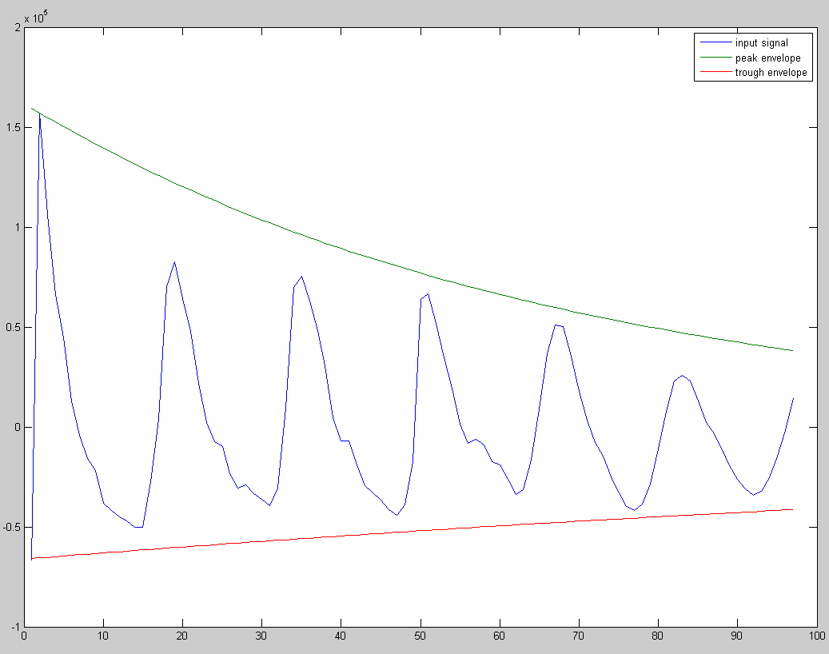
Figure 6: Original signal together with best fit peak and trough envelopes

